.Q 15 Script to rename current working directory with given name.

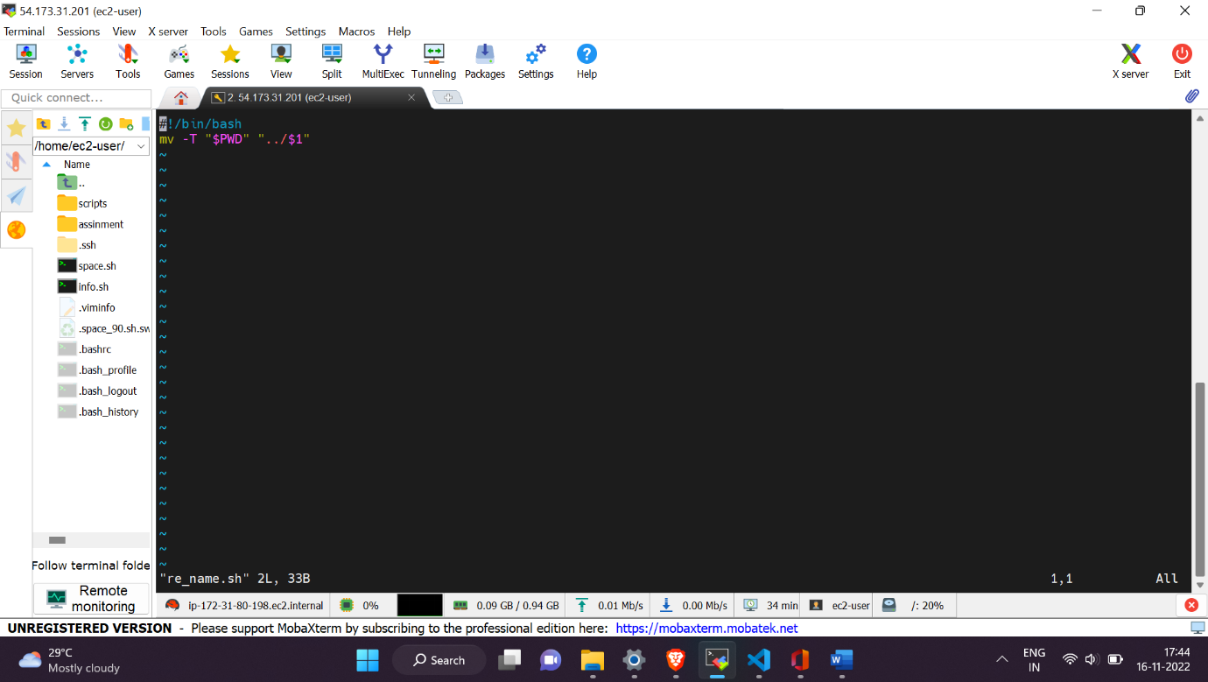

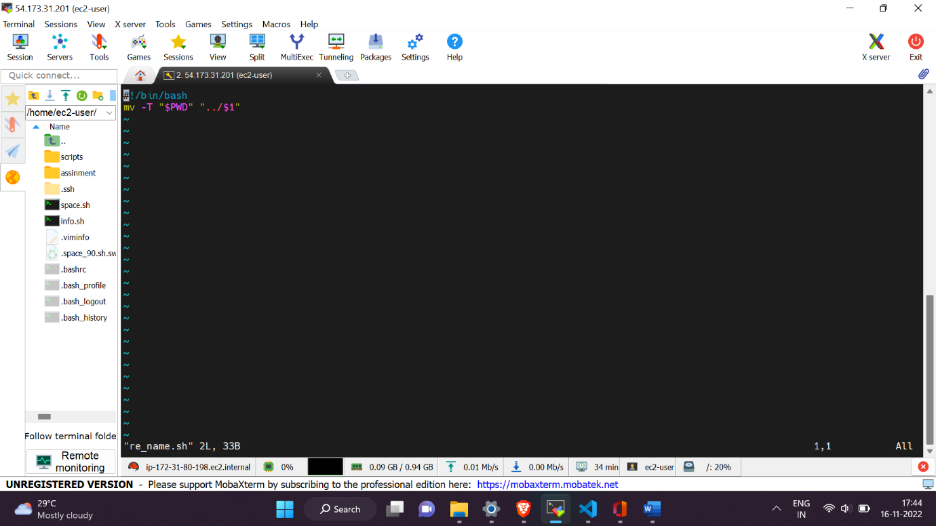

Q Description- Script to print the following

Input-  bash 13_system_info.sh

    1. Currently logged users

    2. Your shell directory

    3. Home directory

    4. OS name & version

    5. Current working directory

    6. Number of users logged in

    7. Show all available shells in your system

    8. Hard disk information

    9. CPU information.

    10.Memory information.

    11.File system information.

    12.Currently running process.

    Enter the option: 3

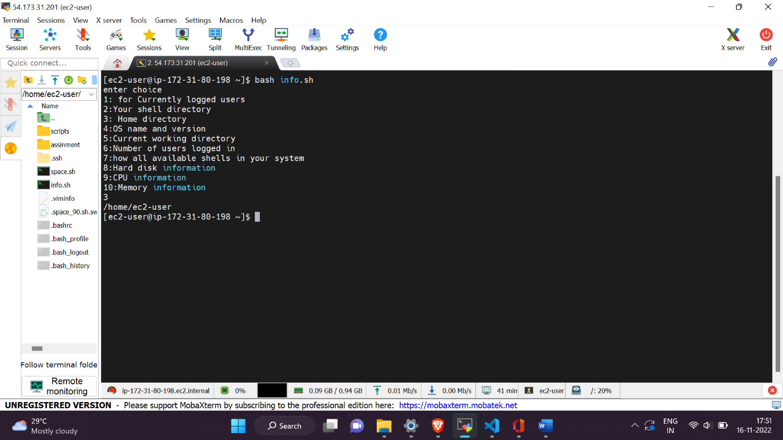

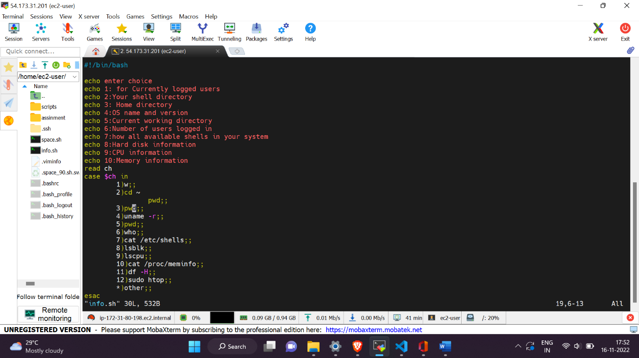

Q .Script to count the number of users with user IDs between 500 and 10000 on the system

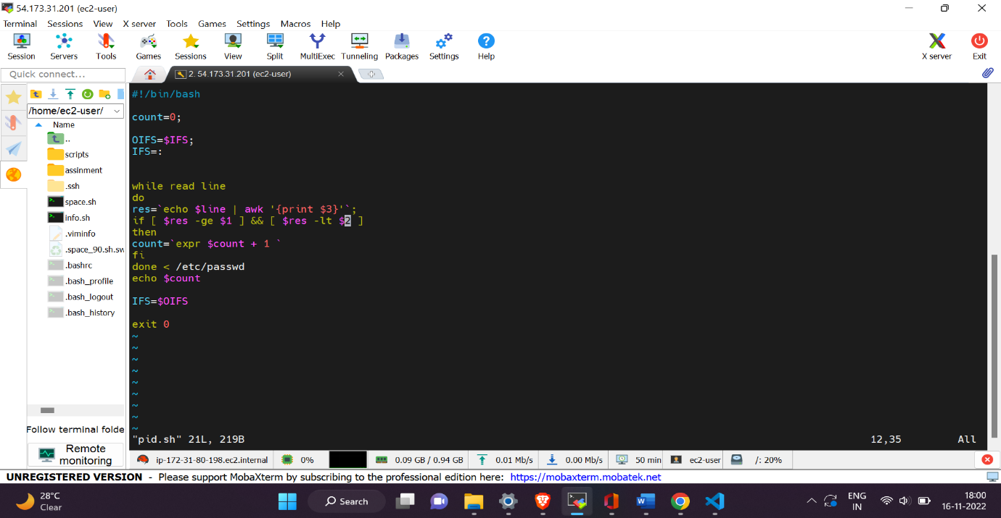

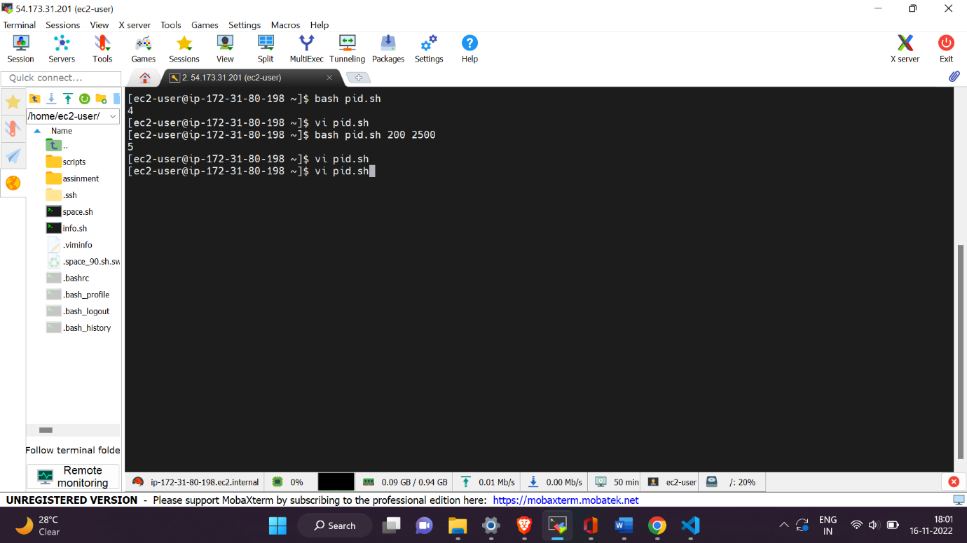

Q .Script to display the longest and shortest user-names on the system.

